**Amazon Simple Notification Service (SNS)**

* SNS is a managed service that provides message delivery to subscribers.
* Publisher communicate asynchronously with subscribers by sending messages to a topic, which is a logical access point and Communication Channel 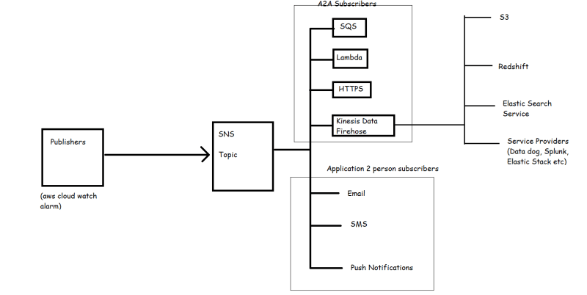
* Lets create an SNS Topic 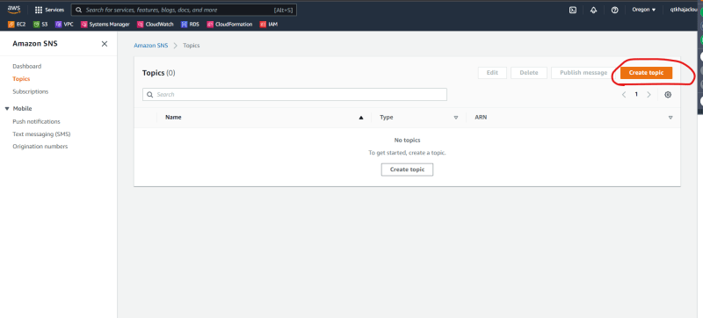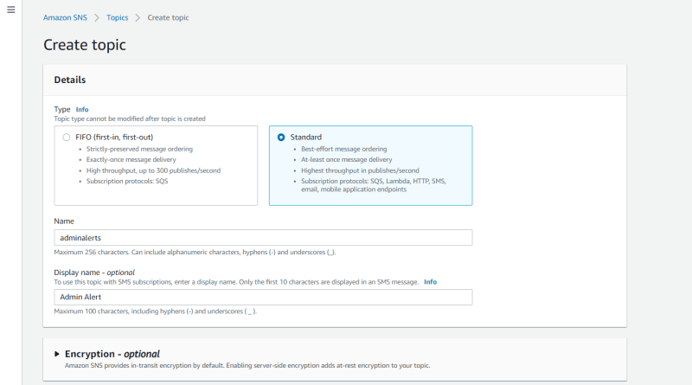
* Now let’s add some email subscriptions. Note: you need to confirm email subscriptions
* Use the topic admin alerts when your cpu is underused 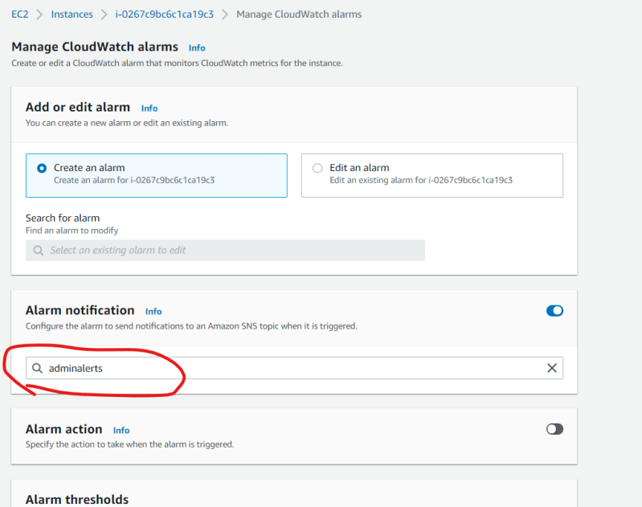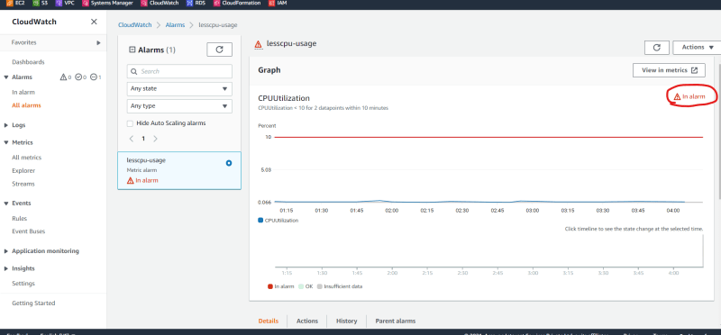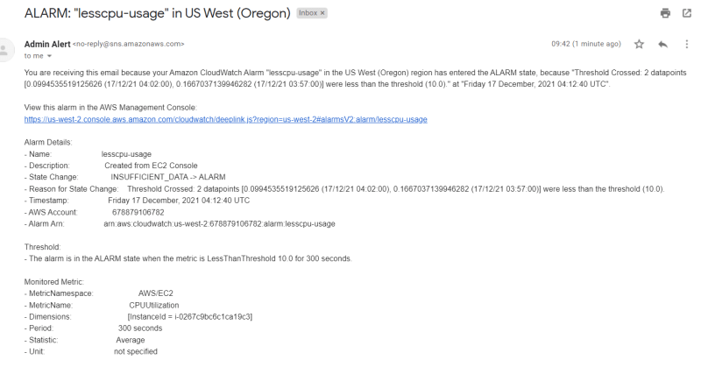

**Activity 2: Create an alert in AWS when your ec2 is overused**

* Lets understand overusage
  + When CPU utilization > 85% for the last 10 minutes
* Actions -> Reboot the System
* Notification -> Send the notification to your admin team.
* After creating the alarm, we can create artificial stress
  + Install a tool called as ‘stress’
* sudo apt install stress
* # amazon linux
* sudo amazon-linux-extras install epel -y
* sudo yum install stress -y

Now run the command stress --cpu 8 --io 4 --vm 2 --vm-bytes 128M --timeout 100m -v 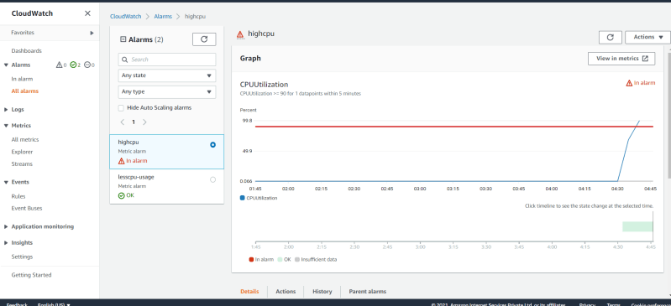

You will receive email alert as well.